# **Name: Abdurrahman Qureshi**

# **Roll No: 242466**

Practical No: 4

1) **Create a table student with 3 columns with NOT NULL constraint**

QUERY:

CREATE TABLE student (

id INT PRIMARY KEY,

name VARCHAR(100) NOT NULL,

age INT NOT NULL,

);

OUTPUT:

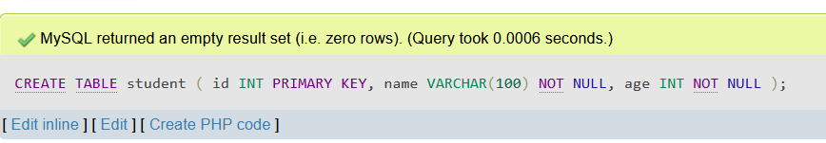

2) **Alter and column DOB**

QUERY:

ALTER TABLE student ADD COLUMN DOB DATE;

OUTPUT:

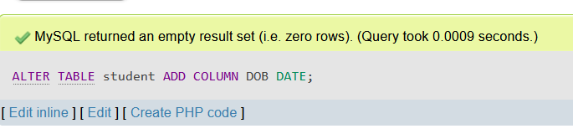

3) **Create a table student with 3 columns with Unique constraint**

QUERY:

CREATE TABLE student (

id INT PRIMARY KEY,

name VARCHAR(100) NOT NULL UNIQUE,

age INT NOT NULL

);

OUTPUT:

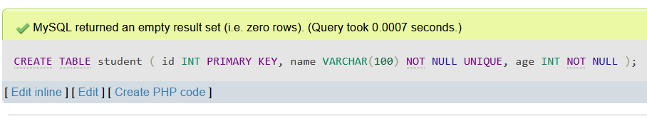

4) **Drop the unique constraint**

QUERY:

ALTER TABLE student DROP CONSTRAINT name;

OUTPUT:

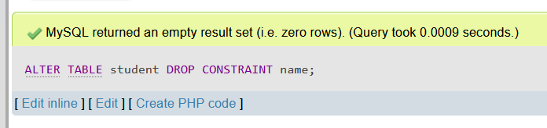

5) **Add a default value of “Mumbai” to the city column**

QUERY:

CREATE TABLE student (

id INT PRIMARY KEY,

name VARCHAR(100) NOT NULL UNIQUE,

age INT NOT NULL,

city VARCHAR(100) DEFAULT "Mumbai",

);

OUTPUT:

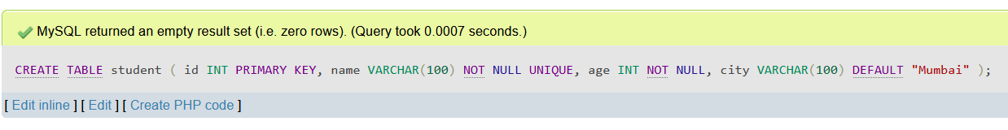

6) **Modify the default value to“Dehli” of the city column**

QUERY:

ALTER TABLE student

ALTER city SET DEFAULT 'Delhi';

OUTPUT:

